**Tutorial: Running ANTx on machines without graphic support “working without graphical user interfaces, GUIs”**

**This tutorial shows how to perform some basic steps without GUIs, for instance when running on a HPC-machine.**

**CONTENTS**

1) OPTIONAL: How to set the paths of ELASTIX in UNIX (LINUX)-systems:

2) OPTIONAL: Open an interactive session on HPC and start Matlab

3) BASICS

ADD ANTx-PATHS

GO TO STUDY-FOLDER

UPDATE ANT-TOOLBOX

CREATE A PROJECT-FILE:

LOAD AN ANTx-PROJECT-FILE ("proj.m")

CHECK WHETHER THE PROJECT-FILE IS LOADED

4) IMPORT BRUKER RAW-DATA

5) VISUALIZE FILES AND FOLDERS

6) SELECTION OF ANIMALS

7) RENAME FILES

8) REGISTER “t2.nii” TO TEMPLATE SPACE (STANDARD SPACE)

9) EXTRACT THE FIRST 3D-VOLUME FROM THE 4D-VOLUME 'dti_b100.nii'

10) COREGISTER 'dti_b100_1stIMG.nii' TO ‘t2.nii’

11) TRANSFORM ANOTHER IMAGE TO STANDARD-SPACE

12) TRANSFORM ANOTHER IMAGE TO NATIVE-SPACE

13) CHECK REGISTRATION in STANDARD-SPACE - CREATE HTML-FILE

14) CHECK REGISTRATION in NATIVE-SPACE - CREATE HTML-FILE

15) REGIONWISE PARAMETER-EXTRACTION

**DTI-preprocessing**

16) DTI-preprocessing: Import DTI/DWI-files from Bruker rawdata

17) DTI-preprocessing: rename DWI-files

18) DTI-preprocessing: A special DTI-atlas is needed

19) DTI-preprocessing: Perform DTI-preprocessing

**1) OPTIONAL: How to set the paths of ELASTIX in UNIX (LINUX)-systems:**

**MAKE ELASTIX RUNNING ON UNIX/LINUX-Systems**

========================================

**1)** **SET PATH OF ELASTIC IN .bashrc-FILE**

========================================

FOR INFORMATION:

see: Elastix-manual (section 3.2)

see: https://usermanual.wiki/Document/elastix490manual.1389615963/html#pf17

**Linux: Add the following lines to your .bashrc file:**

------------------------------------------------------

**export PATH=folder/bin:$PATHexport**

**LD_LIBRARY_PATH=folder/lib:$LD_LIBRARY_PATH**

-----------

...where "folder" is the path to the linux-Elastix-folder (which is located in the antx2-folder): YOUR-DRIVE\antx2\mritools\elastix\elastix_linux64_v4.7

EXAMPLE:

My linux-elastix-folder is "/sc-projects/sc-proj-agtiermrt/Daten-2/ressources/antx2/mritools/elastix/elastix_linux64_v4.7/". Thus, my bahrc-file it modified as follows:

#--------------------------[**ELASTIX-PATH in bashrc**]----------------------------------------

export PATH=/sc-projects/sc-proj-agtiermrt/Daten-2/ressources/antx2/mritools/elastix/elastix_linux64_v4.7/bin:$PATH

export LD_LIBRARY_PATH=/sc-projects/sc-proj-agtiermrt/Daten-2/ressources/antx2/mritools/elastix/elastix_linux64_v4.7/lib:$LD_LIBRARY_PATH

#------------------------------------------------------------------------------------------

========================================

**2)** **RELOAD .bashrc-FILE & TEST ELASTIX**

========================================

- save .bashrc-file, exit editor, than type the following to reload the .bashrc-file again:

**source .bashrc**

- check installation, by typing:

**elastix**

- if successful, a message is displayed:

Use "elastix --help" for information about elastix-usage.

**2) OPTIONAL: Open interactive session on HPC and start Matlab**

**OPEN INTERACTIVE JOB on HPC (optional)**

srun --time 7-00 --mem=64G --ntasks=8 --pty bash -i

-Please check the parameters, here for 7 days, 64 Gb Ram, 8 cores

**LOAD MATLAB-MODULE AND START MATLAB (optional)**

module load scientific/matlab/R2021b

matlab

-to access Matlab might be different on another machine!

**3) BASICS**

**FROM NOW ON type in the MATLAB CMD-WINDOW…**

**ADD ANTx-PATHS**

Go to the ANTx-patd and link all necessary paths using “**antlink**”-command:

cd /sc-projects/sc-proj-agtiermrt/Daten-2/ressources/antx2/

antlink

**GO TO STUDY-FOLDER**

Create an empty study folder (here “groeschel”). The study-folder is the folder where the registration of several animals of a study is performed.

cd /sc-projects/sc-proj-agtiermrt/Daten-2/mri/projects/groeschel/

**UPDATE ANT-TOOLBOX**

This is not mandatory... just type **updateantx(2)** to update the toolbox, i.e. obtain the latest version from GitHub. For more info type help updateantx.

updateantx(2)

**CREATE AN ANTx-PROJECT-FILE:**

makeproject('projectname',fullfile(pwd,'proj.m'), 'voxsize',[.07 .07 .07],'wa_refpath','/sc-projects/sc-proj-agtiermrt/Daten-2/ressources/anttemplates/mouse_Allen2017HikishimaLR','wa_species','mouse');

-here the project-file "**proj.m**" is created using a target voxel size of 0.07 x 0.07 x 0.07 mm, the **animal template** is "**mouse_Allen2017HikishimaLR**", with the species **'mouse'**.

- a suitable template has to be downloaded from google-drive : <https://drive.google.com/drive/folders/1q5XOOVLvUYLqYsQJLqNRF7OK8fNwYhI9>

The template should be unzipped and stored where it could be reached (do not save the downloaded template in the current project-folder!). Creating a project-file has to be done only once!

**LOAD THE PROJECT-FILE "proj.m"**

Here we load the created project-file **“proj.m”:**

loadconfig(fullfile(pwd,'proj.m'));

**CHECK WHETHER THE PROJECT-FILE IS LOADED**

global an;

an

The global variable “an” (struct) contains the basic information for this study. In the CMD-window you should the following:

project: 'NEW PROJECT'

datpath: '/sc-projects/sc-proj-agtiermrt/Daten-2/mri/projects/groeschel/dat'

voxsize: [0.0700 0.0700 0.0700]

wa: [1x1 struct]

**4) IMPORT BRUKER-DATA**

Before doing this step, I just created the ‘raw’-folder within the study’s folder and copied the datasets of two animals into the ‘**raw’**-folder. First we just read the file-information of the Bruker raw-data from the “raw”- folder (fullfile(pwd,'raw')) which is located in the current study folder.

The file-information will be stored in the resulting w-struct.

w=xbruker2nifti(fullfile(pwd,'raw'),0,[],[],'gui',0,'show',1); % first read all data and show it

The w-struct contains the file-information table “d” with header “hd”. This table is listed in the CMD-window when running this command. You could save & reload the struct and import some data later on (advantage: loading time is reduced). To show the table again just type:

w.showtable(w) ; %to show the table in CMD-window

If graphic is supported you could also visualize the table in an extra window via w.showtable2(w) .

Here, the raw-data folder contains two data-sets (i.e. the data from two animals):

¯¯¯¯¯¯¯¯¯¯¯¯¯¯¯¯¯¯¯¯¯¯¯¯¯¯¯¯¯¯¯¯¯¯¯¯¯¯¯¯¯¯¯¯¯¯¯¯¯¯¯¯¯¯¯¯¯¯¯¯¯¯¯¯¯¯¯¯¯¯¯¯¯¯¯¯¯¯¯¯¯¯¯¯¯¯¯¯¯¯¯¯¯¯¯¯¯¯¯¯¯¯¯¯¯¯¯¯¯¯¯¯¯¯¯¯¯¯¯¯¯¯¯¯¯¯¯¯¯¯¯¯¯¯¯¯¯¯¯¯¯¯¯¯¯¯¯¯¯¯¯¯¯¯¯¯¯¯¯¯¯¯¯¯¯¯¯¯¯¯¯¯¯

BRUKER DATA

¯¯¯¯¯¯¯¯¯¯¯¯¯¯¯¯¯¯¯¯¯¯¯¯¯¯¯¯¯¯¯¯¯¯¯¯¯¯¯¯¯¯¯¯¯¯¯¯¯¯¯¯¯¯¯¯¯¯¯¯¯¯¯¯¯¯¯¯¯¯¯¯¯¯¯¯¯¯¯¯¯¯¯¯¯¯¯¯¯¯¯¯¯¯¯¯¯¯¯¯¯¯¯¯¯¯¯¯¯¯¯¯¯¯¯¯¯¯¯¯¯¯¯¯¯¯¯¯¯¯¯¯¯¯¯¯¯¯¯¯¯¯¯¯¯¯¯¯¯¯¯¯¯¯¯¯¯¯¯¯¯¯¯¯¯¯¯¯¯¯¯¯¯

set SubjectId StudNo ExpNo PrcNo MRseq protocol sizeMB date file

1 20200925MG_LAERMRT_MGR000025 1 1 1 FLASH 01_1_Localizer_CRP 0.393216 20-Oct-2020 15:07:20 /sc-projects/sc-proj-agtiermrt/Daten-2/mri/proje

1 20200925MG_LAERMRT_MGR000025 1 10 1 SINGLEPULSE 02_6_freqAdj_SINGLEPULSE 0.004096 20-Oct-2020 15:05:32 /sc-projects/sc-proj-agtiermrt/Daten-2/mri/proje

1 20200925MG_LAERMRT_MGR000025 1 11 1 DtiEpi 02_7_DTI_EPI_seg_b2500_37dir 112.0666 20-Oct-2020 15:06:12 /sc-projects/sc-proj-agtiermrt/Daten-2/mri/proje

1 20200925MG_LAERMRT_MGR000025 1 11 2 DtiEpi nan 129.7613 20-Oct-2020 15:06:59 /sc-projects/sc-proj-agtiermrt/Daten-2/mri/proje

1 20200925MG_LAERMRT_MGR000025 1 13 1 STEAM 04_2_Localized_shim_IC_single 0.004096 20-Oct-2020 15:07:11 /sc-projects/sc-proj-agtiermrt/Daten-2/mri/proje

1 20200925MG_LAERMRT_MGR000025 1 16 1 STEAM 04_3_Localized_shim_MGB 0.004096 20-Oct-2020 15:03:38 /sc-projects/sc-proj-agtiermrt/Daten-2/mri/proje

1 20200925MG_LAERMRT_MGR000025 1 17 1 STEAM 04_3_STEAM_1H_MGB 0.004096 20-Oct-2020 15:05:13 /sc-projects/sc-proj-agtiermrt/Daten-2/mri/proje

1 20200925MG_LAERMRT_MGR000025 1 19 1 STEAM 04_2_Localized_shim_IC_single 0.004096 20-Oct-2020 15:08:29 /sc-projects/sc-proj-agtiermrt/Daten-2/mri/proje

1 20200925MG_LAERMRT_MGR000025 1 2 1 FLASH 01_2_Localizer_multi_slice 1.10592 20-Oct-2020 15:09:05 /sc-projects/sc-proj-agtiermrt/Daten-2/mri/proje

1 20200925MG_LAERMRT_MGR000025 1 20 1 STEAM 04_2_Localized_shim_IC_single 0.004096 20-Oct-2020 15:05:33 /sc-projects/sc-proj-agtiermrt/Daten-2/mri/proje

1 20200925MG_LAERMRT_MGR000025 1 21 1 STEAM 04_2_Localized_shim_IC_single 0.004096 20-Oct-2020 15:04:55 /sc-projects/sc-proj-agtiermrt/Daten-2/mri/proje

1 20200925MG_LAERMRT_MGR000025 1 22 1 FieldMap B0Map-ADJ_B0MAP 1.048576 20-Oct-2020 15:05:31 /sc-projects/sc-proj-agtiermrt/Daten-2/mri/proje

1 20200925MG_LAERMRT_MGR000025 1 23 1 STEAM 04_2_Localized_shim_IC_single 0.004096 20-Oct-2020 15:05:32 /sc-projects/sc-proj-agtiermrt/Daten-2/mri/proje

1 20200925MG_LAERMRT_MGR000025 1 24 1 FLASH 01_2_Localizer_multi_slice 1.10592 20-Oct-2020 15:03:47 /sc-projects/sc-proj-agtiermrt/Daten-2/mri/proje

1 20200925MG_LAERMRT_MGR000025 1 25 1 RARE 03_T2_TurboRARE_CRP_MapShim 2.94912 20-Oct-2020 15:08:28 /sc-projects/sc-proj-agtiermrt/Daten-2/mri/proje

1 20200925MG_LAERMRT_MGR000025 1 26 1 FieldMap B0Map-ADJ_B0MAP 1.048576 20-Oct-2020 15:03:51 /sc-projects/sc-proj-agtiermrt/Daten-2/mri/proje

1 20200925MG_LAERMRT_MGR000025 1 27 1 STEAM 04_2_Localized_shim_IC_single 0.004096 20-Oct-2020 15:04:48 /sc-projects/sc-proj-agtiermrt/Daten-2/mri/proje

1 20200925MG_LAERMRT_MGR000025 1 28 1 STEAM 04_2_STEAM_1H_IC_single 0.004096 20-Oct-2020 15:05:25 /sc-projects/sc-proj-agtiermrt/Daten-2/mri/proje

1 20200925MG_LAERMRT_MGR000025 1 29 1 STEAM 04_3_Localized_shim_MGB 0.004096 20-Oct-2020 15:03:52 /sc-projects/sc-proj-agtiermrt/Daten-2/mri/proje

1 20200925MG_LAERMRT_MGR000025 1 3 1 RARE 03_T2_TurboRARE_CRP 6.5536 20-Oct-2020 15:05:38 /sc-projects/sc-proj-agtiermrt/Daten-2/mri/proje

1 20200925MG_LAERMRT_MGR000025 1 31 1 STEAM 04_2_Localized_shim_IC_single 0.004096 20-Oct-2020 15:05:39 /sc-projects/sc-proj-agtiermrt/Daten-2/mri/proje

1 20200925MG_LAERMRT_MGR000025 1 33 1 STEAM 04_2_Localized_shim_IC_single 0.004096 20-Oct-2020 15:08:23 /sc-projects/sc-proj-agtiermrt/Daten-2/mri/proje

1 20200925MG_LAERMRT_MGR000025 1 35 1 STEAM 04_2_STEAM_1H_IC_single 0.004096 20-Oct-2020 15:07:33 /sc-projects/sc-proj-agtiermrt/Daten-2/mri/proje

1 20200925MG_LAERMRT_MGR000025 1 4 1 DtiEpi 02_1_DTI_EPI_seg_b100_6dir 20.64384 20-Oct-2020 15:08:11 /sc-projects/sc-proj-agtiermrt/Daten-2/mri/proje

1 20200925MG_LAERMRT_MGR000025 1 4 2 DtiEpi nan 129.7613 20-Oct-2020 15:08:24 /sc-projects/sc-proj-agtiermrt/Daten-2/mri/proje

1 20200925MG_LAERMRT_MGR000025 1 5 1 FieldMap B0Map-ADJ_B0MAP 1.048576 20-Oct-2020 15:03:53 /sc-projects/sc-proj-agtiermrt/Daten-2/mri/proje

1 20200925MG_LAERMRT_MGR000025 1 6 1 SINGLEPULSE 02_2_freqAdj_SINGLEPULSE 0.004096 20-Oct-2020 15:05:00 /sc-projects/sc-proj-agtiermrt/Daten-2/mri/proje

1 20200925MG_LAERMRT_MGR000025 1 7 1 DtiEpi 02_3_DTI_EPI_seg_b900_13dir 41.28768 20-Oct-2020 15:08:40 /sc-projects/sc-proj-agtiermrt/Daten-2/mri/proje

1 20200925MG_LAERMRT_MGR000025 1 7 2 DtiEpi nan 129.7613 20-Oct-2020 15:09:00 /sc-projects/sc-proj-agtiermrt/Daten-2/mri/proje

1 20200925MG_LAERMRT_MGR000025 1 8 1 SINGLEPULSE 02_4_freqAdj_SINGLEPULSE 0.004096 20-Oct-2020 15:08:25 /sc-projects/sc-proj-agtiermrt/Daten-2/mri/proje

1 20200925MG_LAERMRT_MGR000025 1 9 1 DtiEpi 02_5_DTI_EPI_seg_b1600_25dir 76.67712 20-Oct-2020 15:04:13 /sc-projects/sc-proj-agtiermrt/Daten-2/mri/proje

1 20200925MG_LAERMRT_MGR000025 1 9 2 DtiEpi nan 129.7613 20-Oct-2020 15:04:41 /sc-projects/sc-proj-agtiermrt/Daten-2/mri/proje

2 20200925MG_LAERMRT_MGR000027 1 1 1 FLASH 01_1_Localizer_CRP 0.393216 20-Oct-2020 14:57:50 /sc-projects/sc-proj-agtiermrt/Daten-2/mri/proje

2 20200925MG_LAERMRT_MGR000027 1 10 1 DtiEpi 02_7_DTI_EPI_seg_b2500_37dir 112.0666 20-Oct-2020 14:56:04 /sc-projects/sc-proj-agtiermrt/Daten-2/mri/proje

2 20200925MG_LAERMRT_MGR000027 1 10 2 DtiEpi nan 129.7613 20-Oct-2020 14:56:29 /sc-projects/sc-proj-agtiermrt/Daten-2/mri/proje

2 20200925MG_LAERMRT_MGR000027 1 11 1 STEAM 04_2_Localized_shim_IC_single 0.004096 20-Oct-2020 14:57:36 /sc-projects/sc-proj-agtiermrt/Daten-2/mri/proje

2 20200925MG_LAERMRT_MGR000027 1 12 1 STEAM 04_2_STEAM_1H_IC_single 0.004096 20-Oct-2020 14:54:36 /sc-projects/sc-proj-agtiermrt/Daten-2/mri/proje

2 20200925MG_LAERMRT_MGR000027 1 13 1 STEAM 04_3_Localized_shim_MGB 0.004096 20-Oct-2020 14:57:43 /sc-projects/sc-proj-agtiermrt/Daten-2/mri/proje

2 20200925MG_LAERMRT_MGR000027 1 14 1 STEAM 04_3_STEAM_1H_MGB 0.004096 20-Oct-2020 14:57:16 /sc-projects/sc-proj-agtiermrt/Daten-2/mri/proje

2 20200925MG_LAERMRT_MGR000027 1 15 1 FieldMap B0Map-ADJ_B0MAP 1.048576 20-Oct-2020 14:59:45 /sc-projects/sc-proj-agtiermrt/Daten-2/mri/proje

2 20200925MG_LAERMRT_MGR000027 1 16 1 STEAM 04_2_Localized_shim_IC_single 0.004096 20-Oct-2020 14:54:32 /sc-projects/sc-proj-agtiermrt/Daten-2/mri/proje

2 20200925MG_LAERMRT_MGR000027 1 17 1 STEAM 04_2_Localized_shim_IC_single 0.004096 20-Oct-2020 14:55:28 /sc-projects/sc-proj-agtiermrt/Daten-2/mri/proje

2 20200925MG_LAERMRT_MGR000027 1 18 1 STEAM 04_2_Localized_shim_IC_single 0.004096 20-Oct-2020 14:56:48 /sc-projects/sc-proj-agtiermrt/Daten-2/mri/proje

2 20200925MG_LAERMRT_MGR000027 1 19 1 STEAM 04_2_Localized_shim_IC_single 0.004096 20-Oct-2020 14:59:15 /sc-projects/sc-proj-agtiermrt/Daten-2/mri/proje

2 20200925MG_LAERMRT_MGR000027 1 2 1 FLASH 01_2_Localizer_multi_slice 1.10592 20-Oct-2020 14:59:33 /sc-projects/sc-proj-agtiermrt/Daten-2/mri/proje

2 20200925MG_LAERMRT_MGR000027 1 20 1 STEAM 04_2_Localized_shim_IC_single 0.004096 20-Oct-2020 14:56:38 /sc-projects/sc-proj-agtiermrt/Daten-2/mri/proje

2 20200925MG_LAERMRT_MGR000027 1 21 1 STEAM 04_2_Localized_shim_IC_single 0.004096 20-Oct-2020 14:54:36 /sc-projects/sc-proj-agtiermrt/Daten-2/mri/proje

2 20200925MG_LAERMRT_MGR000027 1 23 1 STEAM 04_2_Localized_shim_IC_single 0.004096 20-Oct-2020 14:55:32 /sc-projects/sc-proj-agtiermrt/Daten-2/mri/proje

2 20200925MG_LAERMRT_MGR000027 1 3 1 RARE 03_T2_TurboRARE_CRP 6.5536 20-Oct-2020 14:57:06 /sc-projects/sc-proj-agtiermrt/Daten-2/mri/proje

2 20200925MG_LAERMRT_MGR000027 1 4 1 DtiEpi 02_1_DTI_EPI_seg_b100_6dir 20.64384 20-Oct-2020 14:58:07 /sc-projects/sc-proj-agtiermrt/Daten-2/mri/proje

2 20200925MG_LAERMRT_MGR000027 1 4 2 DtiEpi nan 129.7613 20-Oct-2020 14:58:30 /sc-projects/sc-proj-agtiermrt/Daten-2/mri/proje

2 20200925MG_LAERMRT_MGR000027 1 5 1 SINGLEPULSE 02_2_freqAdj_SINGLEPULSE 0.004096 20-Oct-2020 14:54:33 /sc-projects/sc-proj-agtiermrt/Daten-2/mri/proje

2 20200925MG_LAERMRT_MGR000027 1 6 1 DtiEpi 02_3_DTI_EPI_seg_b900_13dir 41.28768 20-Oct-2020 14:54:49 /sc-projects/sc-proj-agtiermrt/Daten-2/mri/proje

2 20200925MG_LAERMRT_MGR000027 1 6 2 DtiEpi nan 129.7613 20-Oct-2020 14:55:18 /sc-projects/sc-proj-agtiermrt/Daten-2/mri/proje

2 20200925MG_LAERMRT_MGR000027 1 7 1 SINGLEPULSE 02_4_freqAdj_SINGLEPULSE 0.004096 20-Oct-2020 14:59:22 /sc-projects/sc-proj-agtiermrt/Daten-2/mri/proje

2 20200925MG_LAERMRT_MGR000027 1 8 1 DtiEpi 02_5_DTI_EPI_seg_b1600_25dir 76.67712 20-Oct-2020 14:58:47 /sc-projects/sc-proj-agtiermrt/Daten-2/mri/proje

2 20200925MG_LAERMRT_MGR000027 1 8 2 DtiEpi nan 129.7613 20-Oct-2020 14:59:07 /sc-projects/sc-proj-agtiermrt/Daten-2/mri/proje

2 20200925MG_LAERMRT_MGR000027 1 9 1 SINGLEPULSE 02_6_freqAdj_SINGLEPULSE 0.004096 20-Oct-2020 14:54:33 /sc-projects/sc-proj-agtiermrt/Daten-2/mri/proje

¯¯¯¯¯¯¯¯¯¯¯¯¯¯¯¯¯¯¯¯¯¯¯¯¯¯¯¯¯¯¯¯¯¯¯¯¯¯¯¯¯¯¯¯¯¯¯¯¯¯¯¯¯¯¯¯¯¯¯¯¯¯¯¯¯¯¯¯¯¯¯¯¯¯¯¯¯¯¯¯¯¯¯¯¯¯¯¯¯¯¯¯¯¯¯¯¯¯¯¯¯¯¯¯¯¯¯¯¯¯¯¯¯¯¯¯¯¯¯¯¯¯¯¯¯¯¯¯¯¯¯¯¯¯¯¯¯¯¯¯¯¯¯¯¯¯¯¯¯¯¯¯¯¯¯¯¯¯¯¯¯¯¯¯¯¯¯¯¯¯¯¯¯

Here we want to import the turboRARE-image **(“03_T2_TurboRARE_CRP.nii”)** and the image **“DTI_EPI_seg_b100_6dir”**.

To visualize the filtered table run the following command (note that the w-struct is used as 1st argument):

w2=xbruker2nifti(w,0,[],[],'gui',0,'show',1,'flt',{'pro','03_T2_TurboRARE_CRP|EPI_seg_b100' } );

the table now looks as follows:

¯¯¯¯¯¯¯¯¯¯¯¯¯¯¯¯¯¯¯¯¯¯¯¯¯¯¯¯¯¯¯¯¯¯¯¯¯¯¯¯¯¯¯¯¯¯¯¯¯¯¯¯¯¯¯¯¯¯¯¯¯¯¯¯¯¯¯¯¯¯¯¯¯¯¯¯¯¯¯¯¯¯¯¯¯¯¯¯¯¯¯¯¯¯¯¯¯¯¯¯¯¯¯¯¯¯¯¯¯¯¯¯¯¯¯¯¯¯¯¯¯¯¯¯¯¯¯¯¯¯¯¯¯¯

BRUKER DATA

¯¯¯¯¯¯¯¯¯¯¯¯¯¯¯¯¯¯¯¯¯¯¯¯¯¯¯¯¯¯¯¯¯¯¯¯¯¯¯¯¯¯¯¯¯¯¯¯¯¯¯¯¯¯¯¯¯¯¯¯¯¯¯¯¯¯¯¯¯¯¯¯¯¯¯¯¯¯¯¯¯¯¯¯¯¯¯¯¯¯¯¯¯¯¯¯¯¯¯¯¯¯¯¯¯¯¯¯¯¯¯¯¯¯¯¯¯¯¯¯¯¯¯¯¯¯¯¯¯¯¯¯¯¯

set SubjectId StudNo ExpNo PrcNo MRseq protocol sizeMB date file

1 20200925MG_LAERMRT_MGR000025 1 3 1 RARE 03_T2_TurboRARE_CRP 6.5536 20-Oct-2020 15:05:38 /sc-projects/sc-

1 20200925MG_LAERMRT_MGR000025 1 4 1 DtiEpi 02_1_DTI_EPI_seg_b100_6dir 20.64384 20-Oct-2020 15:08:11 /sc-projects/sc-

2 20200925MG_LAERMRT_MGR000027 1 3 1 RARE 03_T2_TurboRARE_CRP 6.5536 20-Oct-2020 14:57:06 /sc-projects/sc-

2 20200925MG_LAERMRT_MGR000027 1 4 1 DtiEpi 02_1_DTI_EPI_seg_b100_6dir 20.64384 20-Oct-2020 14:58:07 /sc-projects/sc-

¯

Now let’s import these data. For this just set the ‘show’-parameter to 0:

w2=xbruker2nifti(w,0,[],[],'gui',0,'show',0,'flt',{'pro','03_T2_TurboRARE_CRP|EPI_seg_b100' } );

**5) VISUALIZE FILES AND FOLDERS**

-type **dispfiles** to see a file-by-folder matrix in the command-window (see dispfiles for further help):

dispfiles

The following is displayed in the CMD-window:

¯¯¯¯¯¯¯¯¯¯¯¯¯¯¯¯¯¯¯¯¯¯¯¯¯¯¯¯¯¯¯¯¯¯¯¯¯¯¯¯¯¯¯¯¯¯¯¯¯¯¯¯¯¯¯¯¯¯¯¯¯¯¯¯¯¯¯¯¯¯¯¯¯¯¯¯¯¯¯¯¯¯¯¯¯¯¯¯¯¯¯¯¯¯¯¯¯¯

FILE x FOLDER

¯¯¯¯¯¯¯¯¯¯¯¯¯¯¯¯¯¯¯¯¯¯¯¯¯¯¯¯¯¯¯¯¯¯¯¯¯¯¯¯¯¯¯¯¯¯¯¯¯¯¯¯¯¯¯¯¯¯¯¯¯¯¯¯¯¯¯¯¯¯¯¯¯¯¯¯¯¯¯¯¯¯¯¯¯¯¯¯¯¯¯¯¯¯¯¯¯¯

20200925MG_LAERMRT_MGR000025 20200925MG_LAERMRT_MGR000027 counts

============================ ============================ ======

02_1_DTI_EPI_seg_b100_6dir_1.nii + + 2/2

03_T2_TurboRARE_CRP_1.nii + + 2/2

counts 2/2 2/2

¯¯¯¯¯¯¯¯¯¯¯¯¯¯¯¯¯¯¯¯¯¯¯¯¯¯¯¯¯¯¯¯¯¯¯¯¯¯¯¯¯¯¯¯¯¯¯¯¯¯¯¯¯¯¯¯¯¯¯¯¯¯¯¯¯¯¯¯¯¯¯¯¯¯¯¯¯¯¯¯¯¯¯¯¯¯¯¯¯¯¯¯¯¯¯¯¯¯

Here we see that the study’s “**dat”**-folder now contains two animal-folders (“**20200925MG_LAERMRT_MGR000025**” and “**20200925MG_LAERMRT_MGR000027**”). Each Folder contains the two imported files (**“02_1_DTI_EPI_seg_b100_6dir_1.nii”** and **“03_T2_TurboRARE_CRP_1.nii”).**

**6) SELECTION OF ANIMALS**

Before renaming the files let’s first select the animals we want to process.

Here we will select all animals:

mdirs=antcb(‘getallsubjects’)

Note that the variable “**mdirs**” contains the full paths names of the selected animals:

{'/sc-projects/sc-proj-agtiermrt/Daten-2/mri/projects/groeschel/dat/20200925MG_LAERMRT_MGR000025'}

{'/sc-projects/sc-proj-agtiermrt/Daten-2/mri/projects/groeschel/dat/20200925MG_LAERMRT_MGR000027'}

Alternative selection of all animals:

mdirs =antcb('selectdirs',[1:2 ])

mdirs=antcb('selectdirs','all')

**7) RENAME FILES**

Here we rename the file **'03_T2_TurboRARE_CRP_1.nii'** to ‘t2.nii’. Note that the name convention of **“t2.nii”** is mandatory, because this file is used for registration to standard space. I.e., the registration relies on the name ‘t2.nii’!

The renaming of the file **'03_T2_TurboRARE_CRP_1.nii'** is just because I hate long names.

Let’s rename '03_T2_TurboRARE_CRP_1.nii' to t2.nii':

xrename(0,'03_T2_TurboRARE_CRP_1.nii','t2.nii',':','dirs',mdirs);

and rename '02_1_DTI_EPI_seg_b100_6dir_1.nii' to 'dti_b100.nii':

xrename(0,'02_1_DTI_EPI_seg_b100_6dir_1.nii','dti_b100.nii',':','dirs',mdirs);

Here for safety reasons, we make a copy of the original file and rename the copied file. Note that copying and renaming of the copied version is defined via the colon-symbol (:); the 4th input arg). Alternatively, to rename the original files just keep the 4th arg empty.

Now, we check whether the new files exist via dispfiles:

dispfiles

¯¯¯¯¯¯¯¯¯¯¯¯¯¯¯¯¯¯¯¯¯¯¯¯¯¯¯¯¯¯¯¯¯¯¯¯¯¯¯¯¯¯¯¯¯¯¯¯¯¯¯¯¯¯¯¯¯¯¯¯¯¯¯¯¯¯¯¯¯¯¯¯¯¯¯¯¯¯¯¯¯¯¯¯¯¯¯¯¯¯¯¯¯¯¯¯¯¯

FILE x FOLDER

¯¯¯¯¯¯¯¯¯¯¯¯¯¯¯¯¯¯¯¯¯¯¯¯¯¯¯¯¯¯¯¯¯¯¯¯¯¯¯¯¯¯¯¯¯¯¯¯¯¯¯¯¯¯¯¯¯¯¯¯¯¯¯¯¯¯¯¯¯¯¯¯¯¯¯¯¯¯¯¯¯¯¯¯¯¯¯¯¯¯¯¯¯¯¯¯¯¯

20200925MG_LAERMRT_MGR000025 20200925MG_LAERMRT_MGR000027 counts

============================ ============================ ======

02_1_DTI_EPI_seg_b100_6dir_1.nii + + 2/2

03_T2_TurboRARE_CRP_1.nii + + 2/2

dti_b100.nii + + 2/2

t2.nii + + 2/2

counts 4/4 4/4

¯¯¯¯¯¯¯¯¯¯¯¯¯¯¯¯¯¯¯¯¯¯¯¯¯¯¯¯¯¯¯¯¯¯¯¯¯¯¯¯¯¯¯¯¯¯¯¯¯¯¯¯¯¯¯¯¯¯¯¯¯¯¯¯¯¯¯¯¯¯¯¯¯¯¯¯¯¯¯¯¯¯¯¯¯¯¯¯¯¯¯¯¯¯¯¯¯¯

**8) REGISTER “t2.nii” TO TEMPLATE SPACE (STANDARD SPACE)**

Registration of **“t2.nii”** to standard space is done in 4 steps: [1] initialization, [2] rough rigid registration, [3] segmentation and [4] warping. You can perform these steps (‘task’) isolated & sequentially or combined,. Note however, that task ‘2’ can be only performed when task ‘1’ has been already performed. Here the rough registration is done automatically (autoreg’, 1). We also use parallel processing across animals ('parfor',1); Please check the memory and number of cores when using parallel processing:

xwarp3('batch','task',[1:4 ],'autoreg',1,'parfor',1, 'mdirs',mdirs(:) );

Now let’s check whether the **“t2.nii”** is transformed to standard-space (new name is: **“x_t2.nii”)** and the template **(“AVGT.nii”)** and atlas (**“ANO.nii”)** is back-transformed to native-space (new names: **“ix_ANO.nii”** & **“ix_AVGT.nii”)** via:

dispfiles('flt','^x.*.nii|^ix.*.nii');

¯¯¯¯¯¯¯¯¯¯¯¯¯¯¯¯¯¯¯¯¯¯¯¯¯¯¯¯¯¯¯¯¯¯¯¯¯¯¯¯¯¯¯¯¯¯¯¯¯¯¯¯¯¯¯¯¯¯¯¯¯¯¯¯¯¯¯¯¯¯¯¯¯¯¯¯¯

FILE x FOLDER

¯¯¯¯¯¯¯¯¯¯¯¯¯¯¯¯¯¯¯¯¯¯¯¯¯¯¯¯¯¯¯¯¯¯¯¯¯¯¯¯¯¯¯¯¯¯¯¯¯¯¯¯¯¯¯¯¯¯¯¯¯¯¯¯¯¯¯¯¯¯¯¯¯¯¯¯¯

20200925MG_LAERMRT_MGR000025 20200925MG_LAERMRT_MGR000027 counts

============================ ============================ ======

ix_ANO.nii + + 2/2

ix_AVGT.nii + + 2/2

x_t2.nii + + 2/2

counts 3/3 3/3

¯¯¯¯¯¯¯¯¯¯¯¯¯¯¯¯¯¯¯¯¯¯¯¯¯¯¯¯¯¯¯¯¯¯¯¯¯¯¯¯¯¯¯¯¯¯¯¯¯¯¯¯¯¯¯¯¯¯¯¯¯¯¯¯¯¯¯¯¯¯¯¯¯¯¯¯¯

Here we see that all three files were created for each data set

**9) Extract the first 3d-volume from the 4D-vlume 'dti_b100.nii'**

Use the following command to extract the 1st volume (4th input arg: 1) of **'dti_b100.nii'** and save it as **'dti_b100_1stIMG.nii'** for all animals (mdirs):

xrename(0,'dti_b100.nii' ,'dti_b100_1stIMG.nii' ,'1','dirs', mdirs );

Again, check the existence of the new files via:

dispfiles('flt','^dt')

¯¯¯¯¯¯¯¯¯¯¯¯¯¯¯¯¯¯¯¯¯¯¯¯¯¯¯¯¯¯¯¯¯¯¯¯¯¯¯¯¯¯¯¯¯¯¯¯¯¯¯¯¯¯¯¯¯¯¯¯¯¯¯¯¯¯¯¯¯¯¯¯¯¯¯¯¯¯¯¯¯¯¯¯¯

FILE x FOLDER

¯¯¯¯¯¯¯¯¯¯¯¯¯¯¯¯¯¯¯¯¯¯¯¯¯¯¯¯¯¯¯¯¯¯¯¯¯¯¯¯¯¯¯¯¯¯¯¯¯¯¯¯¯¯¯¯¯¯¯¯¯¯¯¯¯¯¯¯¯¯¯¯¯¯¯¯¯¯¯¯¯¯¯¯¯

20200925MG_LAERMRT_MGR000025 20200925MG_LAERMRT_MGR000027 counts

============================ ============================ ======

dti_b100.nii + + 2/2

dti_b100_1stIMG.nii + + 2/2

counts 2/2 2/2

¯¯¯¯¯¯¯¯¯¯¯¯¯¯¯¯¯¯¯¯¯¯¯¯¯¯¯¯¯¯¯¯¯¯¯¯¯¯¯¯¯¯¯¯¯¯¯¯¯¯¯¯¯¯¯¯¯¯¯¯¯¯¯¯¯¯¯¯¯¯¯¯¯¯¯¯¯¯¯¯¯¯¯¯¯

**10) COREGISTER 'dti_b100_1stIMG.nii' to ‘t2.nii’**

Now let’s coregister the **file 'dti_b100_1stIMG.nii'** (moving image) to the **‘t2.nii’**-image (fixed image):

z=[];

z.TASK={ '[2]' }; ;% flag 2 (or ‘2’) signals to perform coregistration via SPM

z.targetImg1={ 't2.nii' }; ;% TARGET-IMAGE

z.sourceImg1={ 'dti_b100_1stIMG.nii' }; ;% SOURCE-IMAGE

z.sourceImgNum1=[1]; ;% IN CASE OF 4D-vol use 1st 3d-volume of SOURCE

z.applyImg1= '' ; % HERE, THE TRAFO IS NOT APPLIED TO OTHER IMAGES

z.cost_fun='nmi';

z.sep=[7 2 1 0.5 0.1 0.05];

z.tol=[0.01 0.01 0.01 0.001 0.001 0.001];

z.fwhm=[4 4];

z.centerering=[0];

z.reslicing=[1]; ;% OUTPUT-IMAGE IS RESLICED TO MATCH WITH TARGET

z.interpOrder='auto';

z.prefix='r3'; ;% OUTPUT FILE-PREFIX

z.warping=[0]; %WARPING IS "OFF"

z.isparallel=1; ;% PARALLEL PROCESSING ENABLED

xcoreg(0,z, mdirs);

Again, check existence of the registered file:

dispfiles('flt','^r3')

¯¯¯¯¯¯¯¯¯¯¯¯¯¯¯¯¯¯¯¯¯¯¯¯¯¯¯¯¯¯¯¯¯¯¯¯¯¯¯¯¯¯¯¯¯¯¯¯¯¯¯¯¯¯¯¯¯¯¯¯¯¯¯¯¯¯¯¯¯¯¯¯¯¯¯¯¯¯¯¯¯¯¯¯¯¯¯¯¯

FILE x FOLDER

¯¯¯¯¯¯¯¯¯¯¯¯¯¯¯¯¯¯¯¯¯¯¯¯¯¯¯¯¯¯¯¯¯¯¯¯¯¯¯¯¯¯¯¯¯¯¯¯¯¯¯¯¯¯¯¯¯¯¯¯¯¯¯¯¯¯¯¯¯¯¯¯¯¯¯¯¯¯¯¯¯¯¯¯¯¯¯¯¯

20200925MG_LAERMRT_MGR000025 20200925MG_LAERMRT_MGR000027 counts

============================ ============================ ======

r3c_dti_b100_1stIMG.nii + + 2/2

r3c_t2.nii + + 2/2

counts 2/2 2/2

¯¯¯¯¯¯¯¯¯¯¯¯¯¯¯¯¯¯¯¯¯¯¯¯¯¯¯¯¯¯¯¯¯¯¯¯¯¯¯¯¯¯¯¯¯¯¯¯¯¯¯¯¯¯¯¯¯¯¯¯¯¯¯¯¯¯¯¯¯¯¯¯¯¯¯¯¯¯¯¯¯¯¯¯¯¯¯¯¯

Here we see that that the file **‘r3c_dti_b100_1stIMG.nii’** exists for each animal. The file **“r3c_t2.nii**” is just a copy of the unchanged target-file (‘t2.nii’, fixed image).

**11) TRANSFORM ANOTHER IMAGE TO STANDARD-SPACE**

Now, we want to transform the image **“r3c_dti_b100_1stIMG.nii”** to standard-space (1st arg: 1) for all selected animals (mdirs), using b-spline interpolation (4th arg: 4), using the local reorientation information estimated from the rough rigid registration step (5th arg: ‘local’) and indicate that the input-file is located in the animal folder (6th arg: struct('source','intern') . This will create the file **“x_r3c_dti_b100_1stIMG.nii”** in standard-space:

fis=doelastix(1, mdirs,{'r3c_dti_b100_1stIMG.nii'},4,'local' ,struct('source','intern'));

Let’s check the existence of the file **“x_r3c_dti_b100_1stIMG.nii”:**

dispfiles('flt','x_.*')

¯¯¯¯¯¯¯¯¯¯¯¯¯¯¯¯¯¯¯¯¯¯¯¯¯¯¯¯¯¯¯¯¯¯¯¯¯¯¯¯¯¯¯¯¯¯¯¯¯¯¯¯¯¯¯¯¯¯¯¯¯¯¯¯¯¯¯¯¯¯¯¯¯¯¯¯¯¯¯¯¯¯¯¯¯¯¯¯¯¯¯

FILE x FOLDER

¯¯¯¯¯¯¯¯¯¯¯¯¯¯¯¯¯¯¯¯¯¯¯¯¯¯¯¯¯¯¯¯¯¯¯¯¯¯¯¯¯¯¯¯¯¯¯¯¯¯¯¯¯¯¯¯¯¯¯¯¯¯¯¯¯¯¯¯¯¯¯¯¯¯¯¯¯¯¯¯¯¯¯¯¯¯¯¯¯¯¯

20200925MG_LAERMRT_MGR000025 20200925MG_LAERMRT_MGR000027 counts

============================ ============================ ======

ix_ANO.nii + + 2/2

ix_AVGT.nii + + 2/2

ix_AVGThemi.nii + + 2/2

x_r3c_dti_b100_1stIMG.nii + + 2/2

x_t2.nii + + 2/2

counts 5/5 5/5

¯¯¯¯¯¯¯¯¯¯¯¯¯¯¯¯¯¯¯¯¯¯¯¯¯¯¯¯¯¯¯¯¯¯¯¯¯¯¯¯¯¯¯¯¯¯¯¯¯¯¯¯¯¯¯¯¯¯¯¯¯¯¯¯¯¯¯¯¯¯¯¯¯¯¯¯¯¯¯¯¯¯¯¯¯¯¯¯¯¯¯

**12) TRANSFORM ANOTHER IMAGE TO NATIVE-SPACE**

In the same way we could also transform an image from standard-space to the the template space (for instance the Atlas). Here we transform the template’s hemispheric mask **(‘AVGThemi.nii’**) to native space (new name: **‘ix_AVGThemi.nii’**). For transformation to native space the 1st arg is -1, we use NN-interpolation to preserve numbers/hemispheric-IDs (4th arg: 0):

fis2=doelastix(-1, mdirs,{'AVGThemi.nii'},0,'local' ,struct('source','intern'));

Let’s check the existence of the file **‘ix_AVGThemi.nii’**:

dispfiles('flt','ix_.*')

¯¯¯¯¯¯¯¯¯¯¯¯¯¯¯¯¯¯¯¯¯¯¯¯¯¯¯¯¯¯¯¯¯¯¯¯¯¯¯¯¯¯¯¯¯¯¯¯¯¯¯¯¯¯¯¯¯¯¯¯¯¯¯¯¯¯¯¯¯¯¯¯¯¯¯¯¯¯¯¯¯

FILE x FOLDER

¯¯¯¯¯¯¯¯¯¯¯¯¯¯¯¯¯¯¯¯¯¯¯¯¯¯¯¯¯¯¯¯¯¯¯¯¯¯¯¯¯¯¯¯¯¯¯¯¯¯¯¯¯¯¯¯¯¯¯¯¯¯¯¯¯¯¯¯¯¯¯¯¯¯¯¯¯¯¯¯¯

20200925MG_LAERMRT_MGR000025 20200925MG_LAERMRT_MGR000027 counts

============================ ============================ ======

ix_ANO.nii + + 2/2

ix_AVGT.nii + + 2/2

ix_AVGThemi.nii + + 2/2

counts 3/3 3/3

**13) CHECK REGISTRATION in STANDARD-SPACE - CREATE HTML-FILE**

Next, we will create an HTML-file to visualize the overlay of the template **“AVGT.nii”** and **“x_t2.nii”** (animal in standard-space). The 3rd arg defines the output-folder, the 4th input, defines the size of the images and the number of slices to visualize:

checkreghtml(mdirs,{'AVGT.nii','x_t2.nii' },fullfile(pwd,'checks'),struct('size',300,'slices','n20'))

Now you can visualize the registration with your Web-browser. The 1st image is an animated gif, showing the overlay of the **'AVGT.nii'** and **'x_t2.nii’** images. Click onto the image to toggle between the two images, or hit ‘start animation’-button to see the animated gif. The 2nd ('AVGT.nii') and 3rd image ('x_t2.nii') shows the two images side-by-side.

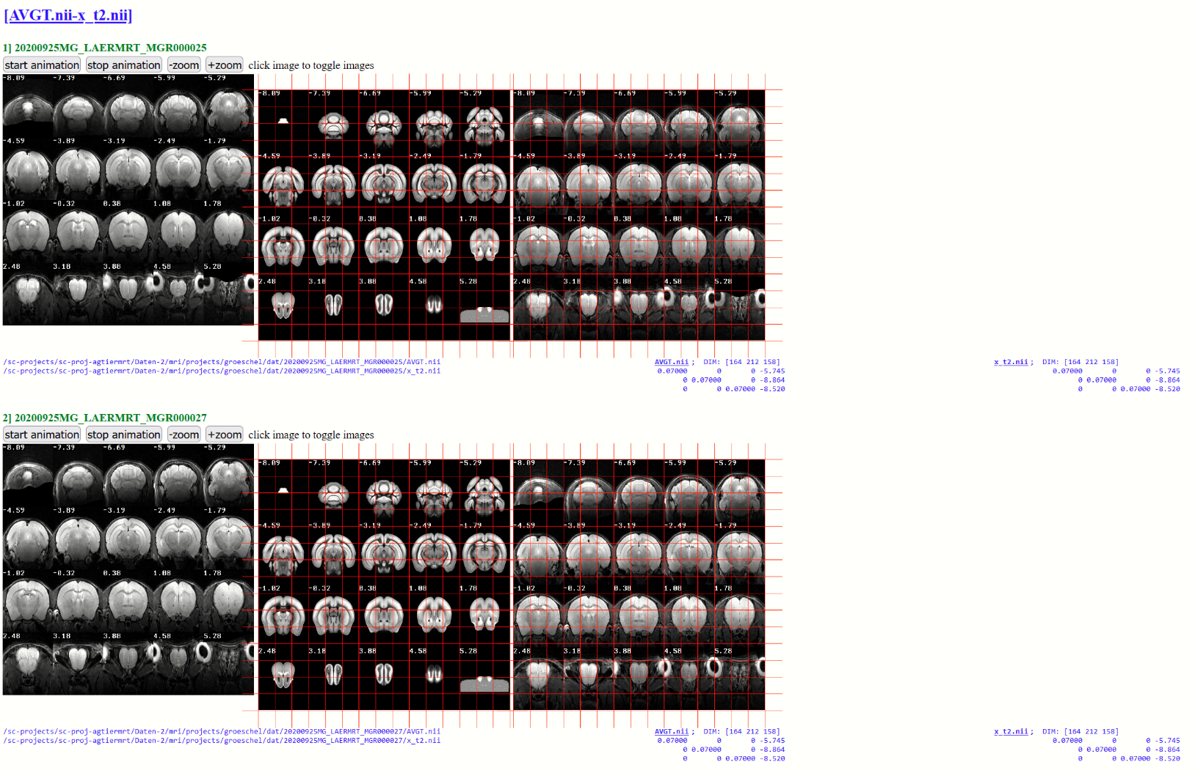

**14) CHECK REGISTRATION in NATIVE-SPACE - CREATE HTML-FILE**

In the same, we can create an overlay of images in native-space. Here we compare the images **“t2.nii”** and **“ix_AVGT.nii”** for all animals and save the output as HTML-file.

Note that the slicing is now done from the 1st-dimension (‘dim’: 1)

checkreghtml(mdirs,{'ix_AVGT.nii','t2.nii' },fullfile(pwd,'checks'),struct('size',300,'slices','n20','dim',1))

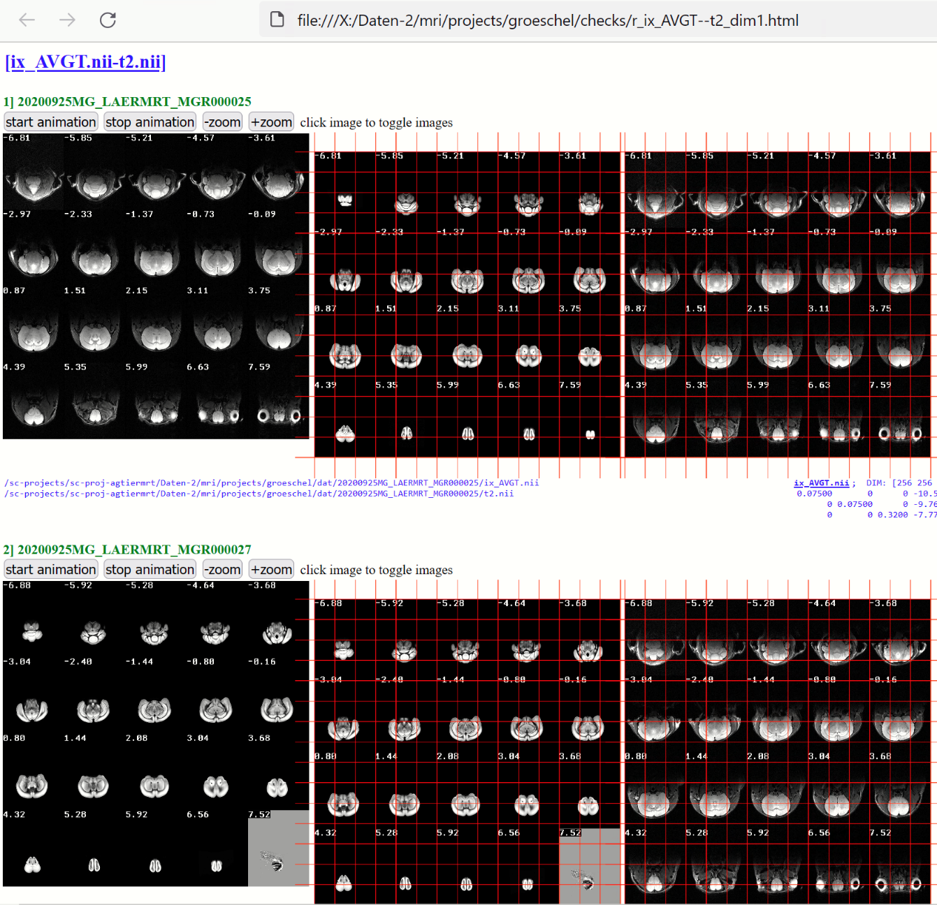

**15) Regionwise parameter-extraction**

We now extract parameters such as volume, mean, median etc. for each region using the image “t2.nii” and the standard atlas (z.atlas= 'ANO.nii'). Here, from the image in native space (z.space= 'native') the parameters are aggregated over the left and right hemisphere (z.hemisphere= 'both').

The resulting Excelfile 'regwise_t2' is stored in the ‘results’-folder (subfolder of the study-folder).

z=[];

z.files = 't2.nii'; % file used for parameter extraction

z.atlas = 'ANO.nii'; % selected atlas name, atlas has to be the standard space atlas name

z.space = 'native'; % use images from “native" space

z.hemisphere = 'both'; % hemisphere used: [left,right or both]

z.fileNameOut = 'regwise_t2' ; % <optional> name of the output-file.

xgetlabels4(0,z,mdirs);

**The resulting excel-file contains a sheet for each parameter. Here see the volume-sheet (“vol”) with region-wise volume in mm3 for each region (rows) and each animal (columns). See “info”-sheet &** xgetlabels4.m **for more information:**

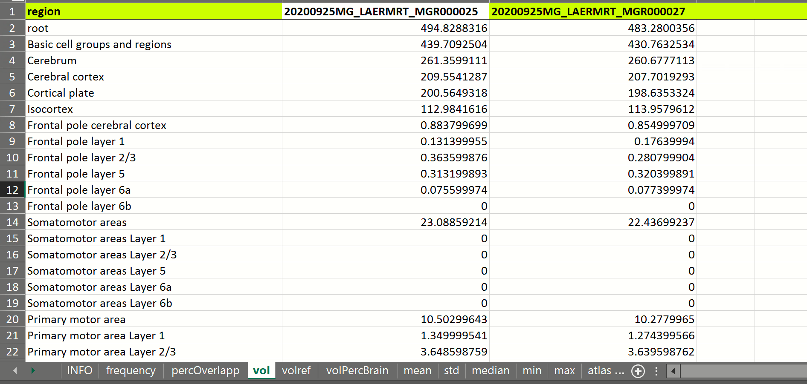

Note: Zero volume entries as for the “somatomotor areas” is because the region-IDs are not defined/exist in the Allen brain Atlas (see also: [**http://atlas.brain-map.org/atlas#atlas=1&plate=100960428&structure=500&x=5245.5&y=3833.5&zoom=-4&resolution=33.45&z=6**](http://atlas.brain-map.org/atlas#atlas=1&plate=100960428&structure=500&x=5245.5&y=3833.5&zoom=-4&resolution=33.45&z=6)**)** Here we see that the layers of “somatomotor areas” are grayed, i.e. not further specified

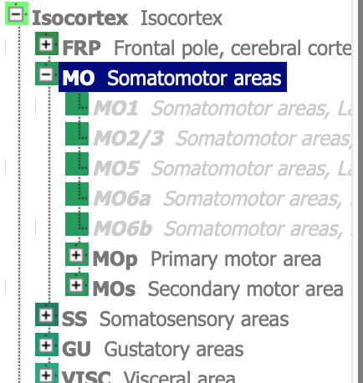

**Of course you could extract parameters from images in standard space as well:**

**Example: Just change the following from the above example:**

z.files = **'x_t2.nii'**; i.e. the t2w-image in standard space is use

z.space = **'standard'**; this indicated that the image is in standard space

z.fileNameOut = **'regwise_x_t2'** just another name for the resulting Excelfile:

**EXAMPLE: PARAMTER EXTRACTION FROM STANDARD SPACE**

z=[];

z.files = 'x_t2.nii'; % file used for parameter extraction

z.atlas = 'ANO.nii'; % selected atlas name, atlas has to be the standard space atlas name

z.space = 'standard'; % use images from "standard” space

z.hemisphere = 'both'; % hemisphere used: [left,right or both]

z.fileNameOut = 'regwise_x_t2' ; % <optional> name of the output-file.

xgetlabels4(0,z,mdirs);

**DTI-preprocessing**

In the upcoming steps we want to prepare the data for the DTI-pipeline, the DTI-processing is done using the MRtrix software package. Several steps have to be done before running the MRtrix-pipeline. Note that a multishell-approach is used for this data.

**16) DTI-preprocessing: Import DTI/DWI-files from Bruker rawdata**

For the preprocessing we first have to import the DWI-files.

First load the struct with the available files from the raw data-folder:

w=xbruker2nifti(fullfile(pwd,'raw'),0,[],[],'gui',0,'show',1);

BRUKER DATA

¯¯¯¯¯¯¯¯¯¯¯¯¯¯¯¯¯¯¯¯¯¯¯¯¯¯¯¯¯¯¯¯¯¯¯¯¯¯¯¯¯¯¯¯¯¯¯¯¯¯¯¯¯¯¯¯¯¯¯¯¯¯¯¯¯¯¯¯¯¯¯¯¯¯¯¯¯¯¯¯¯¯¯¯¯¯¯¯¯¯¯¯¯¯¯¯¯¯

set SubjectId StudNo ExpNo PrcNo MRseq protocol siz..

1..

1 20200925MG_LAERMRT_MGR000025 1 7 1 DtiEpi **02_3_DTI_EPI_seg_b900_13dir** 41…

1 20200925MG_LAERMRT_MGR000025 1 8 1 SINGLEPULSE 02_4_freqAdj_SINGLEPULSE 0.0..

1 20200925MG_LAERMRT_MGR000025 1 9 1 **DtiEpi 02_5_DTI_EPI_seg_b1600**_25dir 76…

..

2 20200925MG_LAERMRT_MGR000027 1 5 1 SINGLEPULSE 02_2_freqAdj_SINGLEPULSE 0.0..

2 20200925MG_LAERMRT_MGR000027 1 6 1 DtiEpi **02_3_DTI_EPI_seg_b900_13dir** 41…

2 20200925MG_LAERMRT_MGR000027 1 6 2 DtiEpi nan 129..

..

2 20200925MG_LAERMRT_MGR000027 1 8 1 **DtiEpi 02_5_DTI_EPI_seg_b1600**_25dir 76…

2 20200925MG_LAERMRT_MGR000027 1 9 1 SINGLEPULSE 02_6_freqAdj_SINGLEPULSE 0.0..

..

The cmd-window displays all available files. Here we are interested in the files which protocol-name contains the string “DTI_EPI_seg_” (bold) . To filter those files we use:

w2=xbruker2nifti(w,0,[],[],'gui',0,'show',1,'flt',{'pro','EPI_seg_'});

BRUKER DATA

¯¯¯¯¯¯¯¯¯¯¯¯¯¯¯¯¯¯¯¯¯¯¯¯¯¯¯¯¯¯¯¯¯¯¯¯¯¯¯¯¯¯¯¯¯¯¯¯¯¯¯¯¯¯¯¯¯¯¯¯¯¯¯¯¯¯¯¯¯¯¯¯¯¯¯¯¯¯¯¯¯¯¯¯¯¯¯¯¯¯¯¯¯¯¯¯¯¯

set SubjectId StudNo ExpNo PrcNo MRseq protocol sizeMB

1 20200925MG_LAERMRT_MGR000025 1 11 1 DtiEpi 02_7_DTI_EPI_seg_b2500_37dir 112.0666

1 20200925MG_LAERMRT_MGR000025 1 4 1 DtiEpi 02_1_DTI_EPI_seg_b100_6dir 20.64384

1 20200925MG_LAERMRT_MGR000025 1 7 1 DtiEpi 02_3_DTI_EPI_seg_b900_13dir 41.28768

1 20200925MG_LAERMRT_MGR000025 1 9 1 DtiEpi 02_5_DTI_EPI_seg_b1600_25dir 76.67712

2 20200925MG_LAERMRT_MGR000027 1 10 1 DtiEpi 02_7_DTI_EPI_seg_b2500_37dir 112.0666

2 20200925MG_LAERMRT_MGR000027 1 4 1 DtiEpi 02_1_DTI_EPI_seg_b100_6dir 20.64384

2 20200925MG_LAERMRT_MGR000027 1 6 1 DtiEpi 02_3_DTI_EPI_seg_b900_13dir 41.28768

2 20200925MG_LAERMRT_MGR000027 1 8 1 DtiEpi 02_5_DTI_EPI_seg_b1600_25dir 76.67712

¯

Now let’s import those files by setting the ‘show’-flag to 0:

w2=xbruker2nifti(w,0,[],[],'gui',0,'show',0,'flt',{'pro','EPI_seg_'});

Use dispfiles to check whether the data where imported for our two animals:

dispfiles('flt','EPI_seg');

¯¯¯¯¯¯¯¯¯¯¯¯¯¯¯¯¯¯¯¯¯¯¯¯¯¯¯¯¯¯¯¯¯¯¯¯¯¯¯¯¯¯¯¯¯¯¯¯¯¯¯¯¯¯¯¯¯¯¯¯¯¯¯¯¯¯¯¯¯¯¯¯¯¯¯¯¯¯¯¯¯¯¯¯¯¯¯¯¯¯¯¯¯¯¯¯¯¯

FILE x FOLDER

¯¯¯¯¯¯¯¯¯¯¯¯¯¯¯¯¯¯¯¯¯¯¯¯¯¯¯¯¯¯¯¯¯¯¯¯¯¯¯¯¯¯¯¯¯¯¯¯¯¯¯¯¯¯¯¯¯¯¯¯¯¯¯¯¯¯¯¯¯¯¯¯¯¯¯¯¯¯¯¯¯¯¯¯¯¯¯¯¯¯¯¯¯¯¯¯¯¯

counts 20200925MG_LAERMRT_MGR000025 20200925MG_LAERMRT_MGR0000

====== ============================ ==========================

counts 4/4 4/4

====== ============================ ==========================

02_1_DTI_EPI_seg_b100_6dir_1.nii 2/2 + +

02_3_DTI_EPI_seg_b900_13dir_1.nii 2/2 + +

02_5_DTI_EPI_seg_b1600_25dir_1.nii 2/2 + +

02_7_DTI_EPI_seg_b2500_37dir_1.nii 2/2 + +

¯¯¯

Here we see that for the two animals 4 DWI-files where imported

**17) DTI-preprocessing: rename DWI-files**

First select all animal-dirs. Let’s make a copy of the DWI-files files and renames them to make it easier. Note that the colon-sign (:) as 4th input arg of in **xrename** result in a copy of the files (If you want to rename the original file just keep the 4th arg empty).

mdirs=antcb('selectdirs','all')

xrename(0,'02_1_DTI_EPI_seg_b100_6dir_1.nii' ,'q_b100.nii' ,':','dirs',mdirs);

xrename(0,'02_3_DTI_EPI_seg_b900_13dir_1.nii' ,'q_b900.nii' ,':','dirs',mdirs);

xrename(0,'02_5_DTI_EPI_seg_b1600_25dir_1.nii' ,'q_b1600.nii',':','dirs',mdirs);

xrename(0,'02_7_DTI_EPI_seg_b2500_37dir_1.nii' ,'q_b2500.nii',':','dirs',mdirs);

Let’s check files via dispfiles:

dispfiles('flt','q_b');

¯¯¯¯¯¯¯¯¯¯¯¯¯¯¯¯¯¯¯¯¯¯¯¯¯¯¯¯¯¯¯¯¯¯¯¯¯¯¯¯¯¯¯¯¯¯¯¯¯¯¯¯¯¯¯¯¯¯¯¯¯¯¯¯¯¯¯¯¯¯¯¯¯¯¯¯¯

FILE x FOLDER

¯¯¯¯¯¯¯¯¯¯¯¯¯¯¯¯¯¯¯¯¯¯¯¯¯¯¯¯¯¯¯¯¯¯¯¯¯¯¯¯¯¯¯¯¯¯¯¯¯¯¯¯¯¯¯¯¯¯¯¯¯¯¯¯¯¯¯¯¯¯¯¯¯¯¯¯¯

counts 20200925MG_LAERMRT_MGR000025 20200925MG_LAERMRT_MGR000027

====== ============================ ============================

counts 4/4 4/4

====== ============================ ============================

q_b100.nii 2/2 + +

q_b1600.nii 2/2 + +

q_b2500.nii 2/2 + +

q_b900.nii 2/2 + +

¯¯¯¯¯¯¯¯¯¯¯¯¯¯¯¯¯¯¯¯¯¯¯¯¯¯¯¯¯¯¯¯¯¯¯¯¯¯¯¯¯¯¯¯¯¯¯¯¯¯¯¯¯¯¯¯¯¯¯¯¯¯¯¯¯¯¯¯¯¯¯¯¯¯¯¯¯

Here we see that for the two animals copies of the 4 DWI-files where created with simpler filenames.

**18) DTI-preprocessing: A special DTI-atlas is needed**

We need a special atlas with comparable fewer regions for DTI-processing (compared to the Allen mouse brain atlas, ABA). Otherwise the parcellation would be too fine-grained. For this, a NIFTI-file with regions of interest (regions partially merged from fine-grained regions from the ABA) was created **(‘atl_auditsys_08dec20.nii’,** here termed “DWI/DTI-filename”**).** Additionally a corresponding look-up-table was created (**‘atl_auditsys_08dec20_INFO.txt’,** here termed “lutfile”) which contains the region IDs in subsequent order and looks as follows:

#ID Labelname R G B A

1 L_Supplemental_somatosensory_area_layer_6b_MODIF 24 128 100 255

2 L_Ventral_auditory_area_layer_6b_MODIF 1 147 153 255

3 L_Primary_auditory_area_layer_6b_MODIF 1 147 153 255

4 L_Postrhinal_area_layer_6b_MODIF 8 133 140 255

5 L_Anterior_cingulate_area_ventral_part_6b_MODIF 64 166 102 255

…

36 R_Nucleus_y_MODIF 255 179 217 255

37 R_Flocculus_MODIF 255 252 145 255

38 R_Triangular_nucleus_of_septum_MODIF 150 167 211 255

For sake of simplicity, a new folder ‘atl_auditsys_08dec20_v1’ was created in the study-folder which contains these two files (Note that these files are needed for DTI-processing using MRtrix).

To create your own Atlas you could use **ANT-Menu: Tools/”Make Atlas From Excelfile**” (xexcel2atlas.m). Before doing that you have to make a local copy the “ANO.xlsx”-file and add (somewhere) two columns:

1) a column with new IDs for those regions that should appear in the new atlas. The same new IDs can be given to regions that should be merged (i.e incorporated into one larger region). Keep sequential order (i.e do not use ID=20 if lower IDs are newer given in the new atlas)

2) a column that define the hemispheric set-up (such as splitted region for left and right hemisphere) … see help of **xexcel2atlas.m**.

**19) DTI-preprocessing: Perform DTI-preprocessing**

The registration of “t2.nii” to standard-space is mandatory before performing the DTI-preprocessing step. Luckily, we have already done this in step-8 (REGISTER “t2.nii” TO TEMPLATE SPACE (STANDARD SPACE)). The DTI-preprocessing steps contains a number of operations:

**(1) Prepare data**

-make DTI-folder & create the DTIprep-struct

-assign a sample Bruker-raw data set to extract the b-tables

-assign DTI-atlas (d.DTItemplate & d.DTItemplateLUT) (.. those from above..:-)

-assign DWI/DTI-files (d.DTIfileName)

**(2) perform the following tasks:**

1. distribute files -> copy DTI-atlas/lutfile & b-tables to animal-dirs

2. deform files -> transform DTIatlas, brainmask etc. to native space

3. register files -> register "t2.nii" to DWI-file, than apply trafo to native space files such as

("ix_"+DTIatlas, "ix"+brainmask etc.)

4. rename files -> rename files (names are fixed and names are expected from shellscripts)

5 export files -> export files to "DTI_export4mrtrix"-folder (OPTIONAL STEP!)

6 check registration-> create HTML-files with overlays of images to visualize the coregistration

-this step is done using the data from the 'dat'-folder (not the export-folder!)

-HTML-files are stored in the "checks"-folder within the study's folder

-OPTIONAL STEP!

First for safety reasons let’s first delete the “DTI”-folder within the study-folder. Note that the “DTI”-folder will be created in the next step and will contain basic parameters, the b-tables and the DTI-atlas & lutfile.

**DTIprep('delete');**

Now we prepare the data and assign the following variables:

(1) assign the fullpath name of one Bruker rawdata set. This is necessary to obtain the b-tables (**d.brukerdata**).

(2) assign the fullpath name of the DTI-atlas (NIFTI-file, **d.DTItemplate**)

(3) assign the fullpath name of the lutfile (textfile with region-IDs, **d. DTItemplateLUT**)

(4) assign the short names of the DWI-files (files should now exist in the animal-dirs (**d.DTIfileName**). Please preserve the order of the DWI-files (100,900,1600,2500).

**clear d;**

**d.brukerdata = fullfile(pwd,'raw','20200925_092655_20200925MG_LAERMRT_MGR000025_1_1');**

**d.DTItemplate = fullfile(pwd,'atl_auditsys_08dec20_v1','atl_auditsys_08dec20.nii');**

**d.DTItemplateLUT =fullfile(pwd,'atl_auditsys_08dec20_v1','atl_auditsys_08dec20_INFO.txt');**

**d.DTIfileName={'q_b100.nii' 'q_b900.nii' 'q_b1600.nii' 'q_b2500.nii'};**

**now run the initialization step:**

**DTIprep('ini',d);** % initialize DTIprep-struct and fill requested parameters

The cmd-window displays the content of the DTIprep-struct:

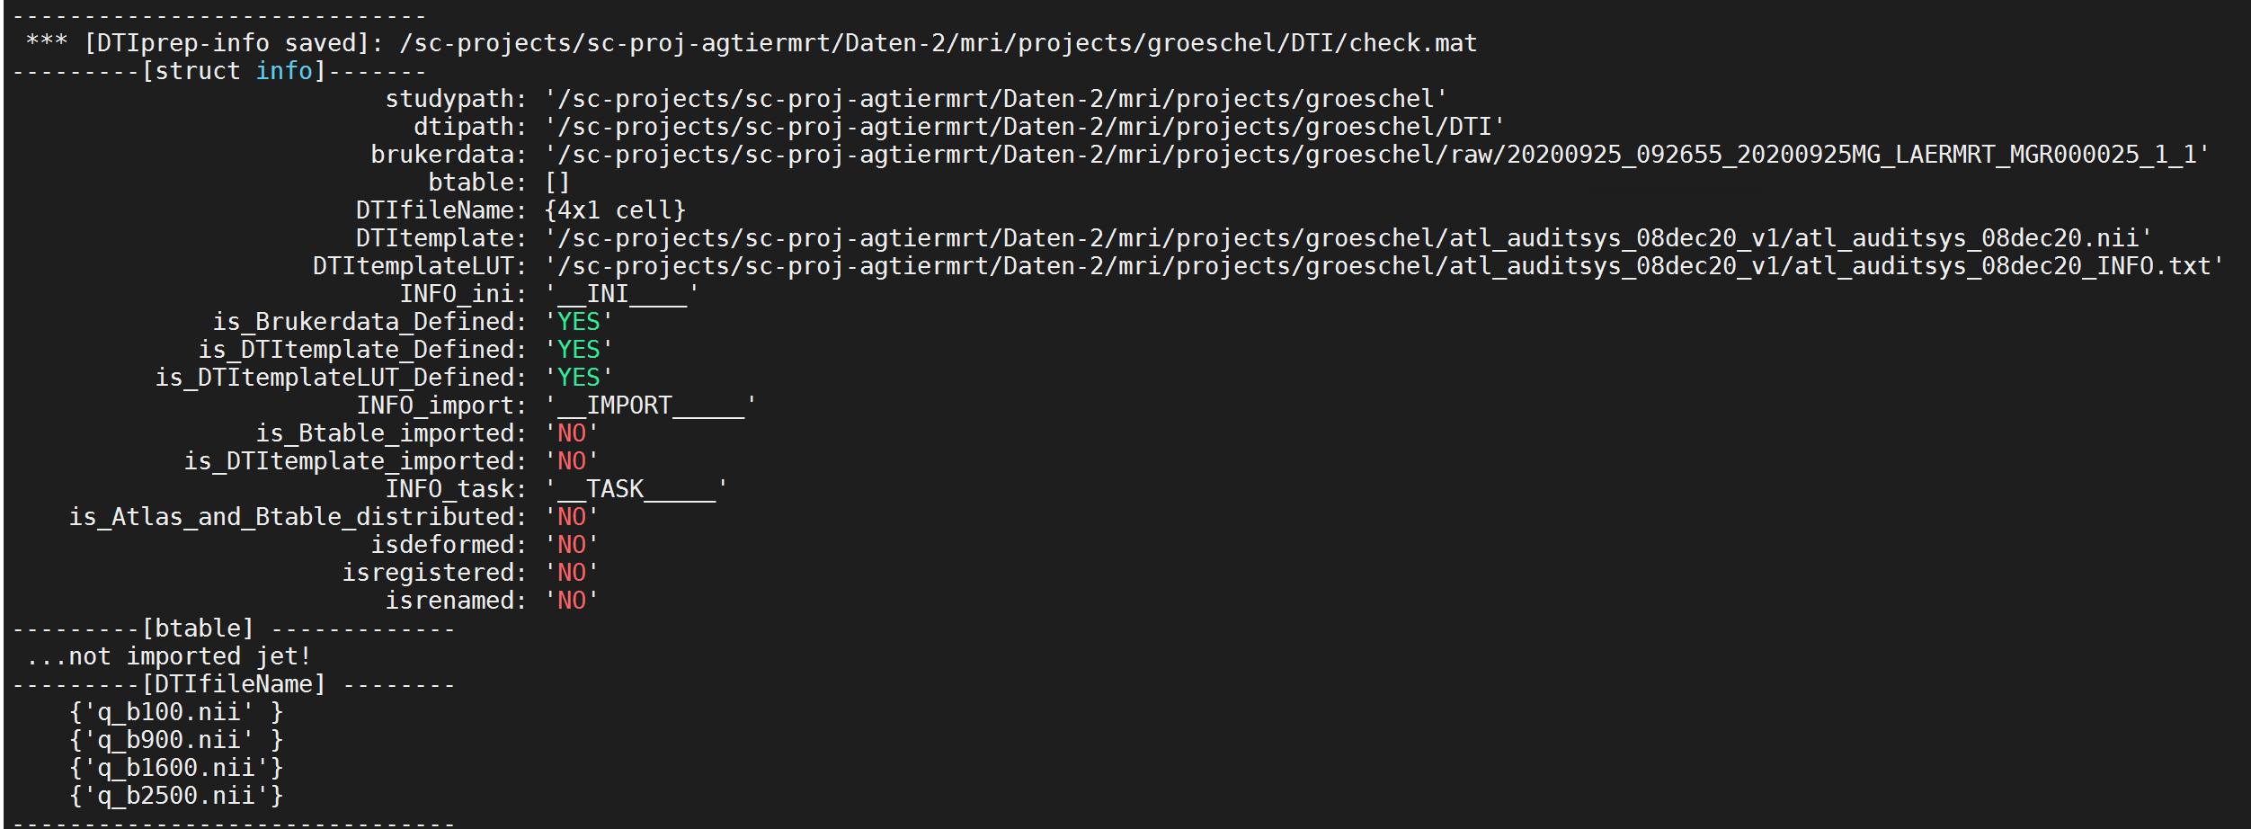

…with “YES” for all “initialization” steps.

Now, let’s **import** the B-tables from the raw-data and the DTI-atlas (DTItemplate/lutfile)

**DTIprep('import');** % import b-table and DTItemplate/DTItemplateLUT

The cmd-window should display the found B-tables (source/output/number of aqu. directions):

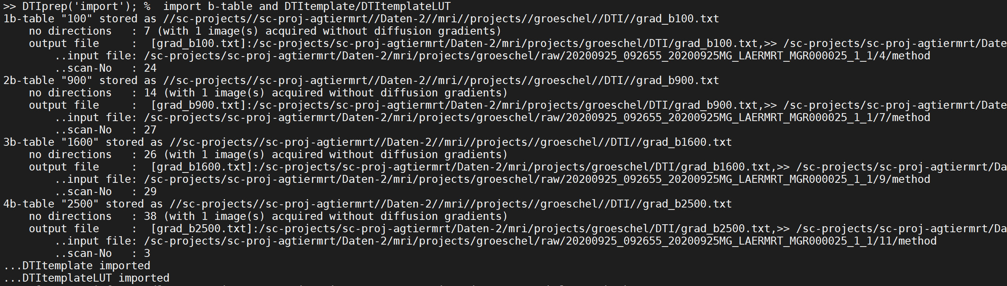

The DTIprep-struct should now look as follows: 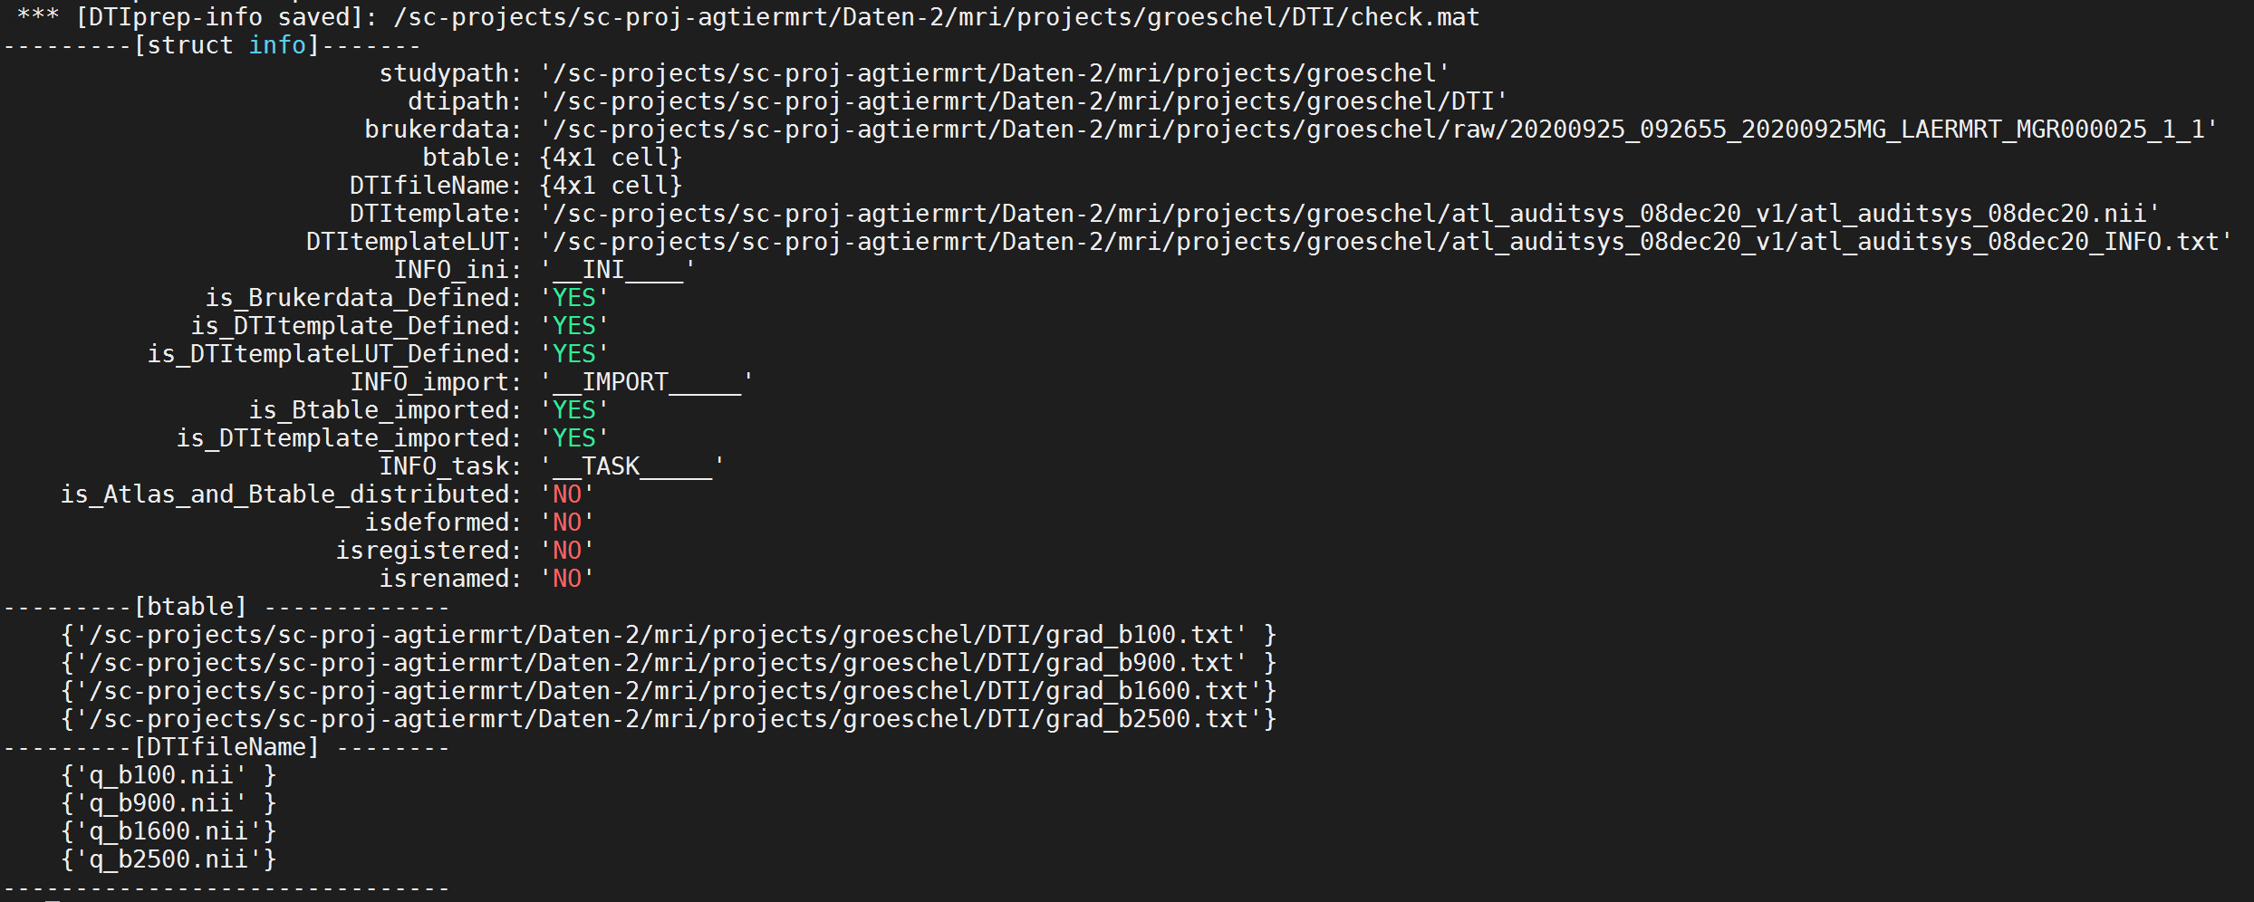

…with “YES” for all “import”-steps.

To show the status of the DTIprep struct again just type :

**DTIprep('check');**

Note that the information is stored in the DTIprep-struct and you can also close the session and resume later on (just type: DTIprep or DTIprep('check');

Please note that the order of the B-tables ans DTI/DWI-files should match and should start from lowest to highest number (100,900,1600,2500). If this is not the case use either DTIprep('reorder','b',<reorderIndex>) or DTIprep('reorder','d',<reorderIndex>) to reorder the B-tables and/or DWIfiles, respectively, example:

DTIprep('reorder','b',[1 4 3 2]) ; % to reoder files of 'DTIfileName' accord index 1,4,3,3

DTIprep('reorder','d',[1 2 4 3]) ; %reoder files of 'btable' accord index 1,2,4,3

After the initialization- and import-steps we next perform the following tasks:

(1) distribute files, (2) deform files, (3) register files, (4) rename files, (5) export files and (6) check registration. These tasks have to be performed in that order (except step 5 and 6; both tasks are optional). Note that the tasks can be performed sequentially; example: DTIprep('run',1:2,mdirs); % to run the step-1 and step-2 only.

In order to run all 6 tasks we can run DTIprep('run',1:6,mdirs) or simply DTIprep('run','all',mdirs):

DTIprep('run','all',mdirs);

When DTI-preprocessing is finished we can check the status of the DTIprep struct again:

**DTIprep('check');**

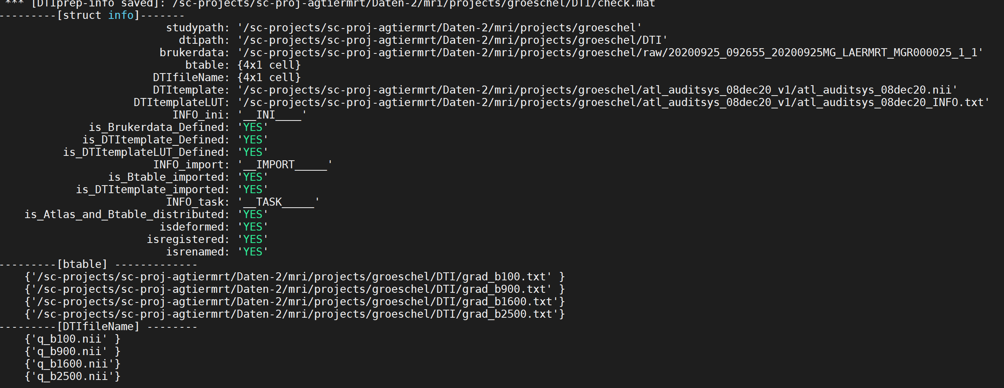

Note that “YES” is displayed for all mandatory tasks.

The study folder should now contain a new folder “**DTI_export4mrtrix**” with all data necessary for DTI-processing (except the shellscripts).

DTI_export4mrtrix

└───dat

├───20200925MG_LAERMRT_MGR000027

└───20200925MG_LAERMRT_MGR000025

Each of the exported anima-folder contains the following files (multishell-approach):

'ANO_DTI.nii' -DTI-atlas, back-transformed to native space and than

transformed to DWI-space,renamed

'ANO_DTI.txt' -DTI-labels lookup table,renamed

'atlas_lut.txt' -DTI-labels lookup table (copy of 'ANO_DTI.txt'),renamed

'rc_ix_AVGTmask.nii' -brain mask, back-transformed to native space and

transformed+resliced to DWI-space

'rc_mt2.nii' -bias-corected t2.nii,transformed+resliced to DWI-space

'rc_t2.nii' -t2.nii,transformed+resliced to DWI-space

'dwi_b100.nii' -original DWI-file, copied & renamed

'dwi_b1600.nii' ||

'dwi_b3400.nii' ||

'dwi_b6000.nii' ||

'grad_b100.txt' b-table

'grad_b1600.txt' ||

'grad_b3400.txt' ||

'grad_b6000.txt' ||

It is necessary to check that the registration of the images is in line with the DWI-file (1st 4D-DWI-volume: 'dwi_b100.nii'). Task-6 of the DTIprep-command did this and HTML-files where created in the “checks”-folder. We visually inspect the registration quality and check whether the data are ready for DTIprocessing using MRtrix.

When open the “index.html” (in the “checks”-folder) in a browser we can inspect the coregistration with the 1st DWI-file. Note that the registration of the other DWI-files is done within the MRtrix-pipeline. (Again, that’s the reason why B-tables and DWI/DTIfiles should be ordered from lowest to highest and should match):

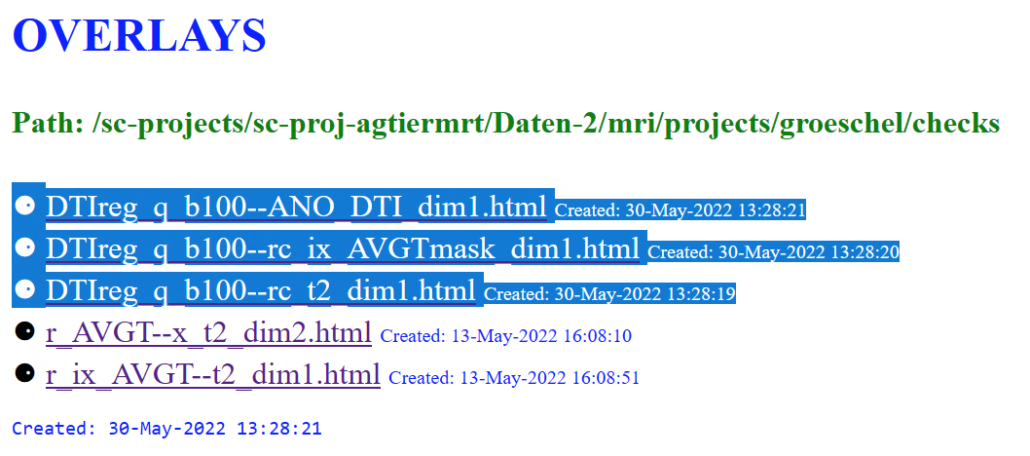

Images below: overlay of the 1st DWI-file (“q_b100.nii”) with “rc_t2.nii” (left), “rc_ixAVGTmask.nii” (right) and “ANO.nii” (bottom). In the browser: click left image to toggle between foreground and background images. Note that the HTML-files are created from the data of the “dat”-folder (not from the export-folder “DTI_export4mrtrix”, because exporting the data is optional). Note that the DWI-files are preserved (fixed image) while all other images (moving images) are registered to the 1st. DWI-file.

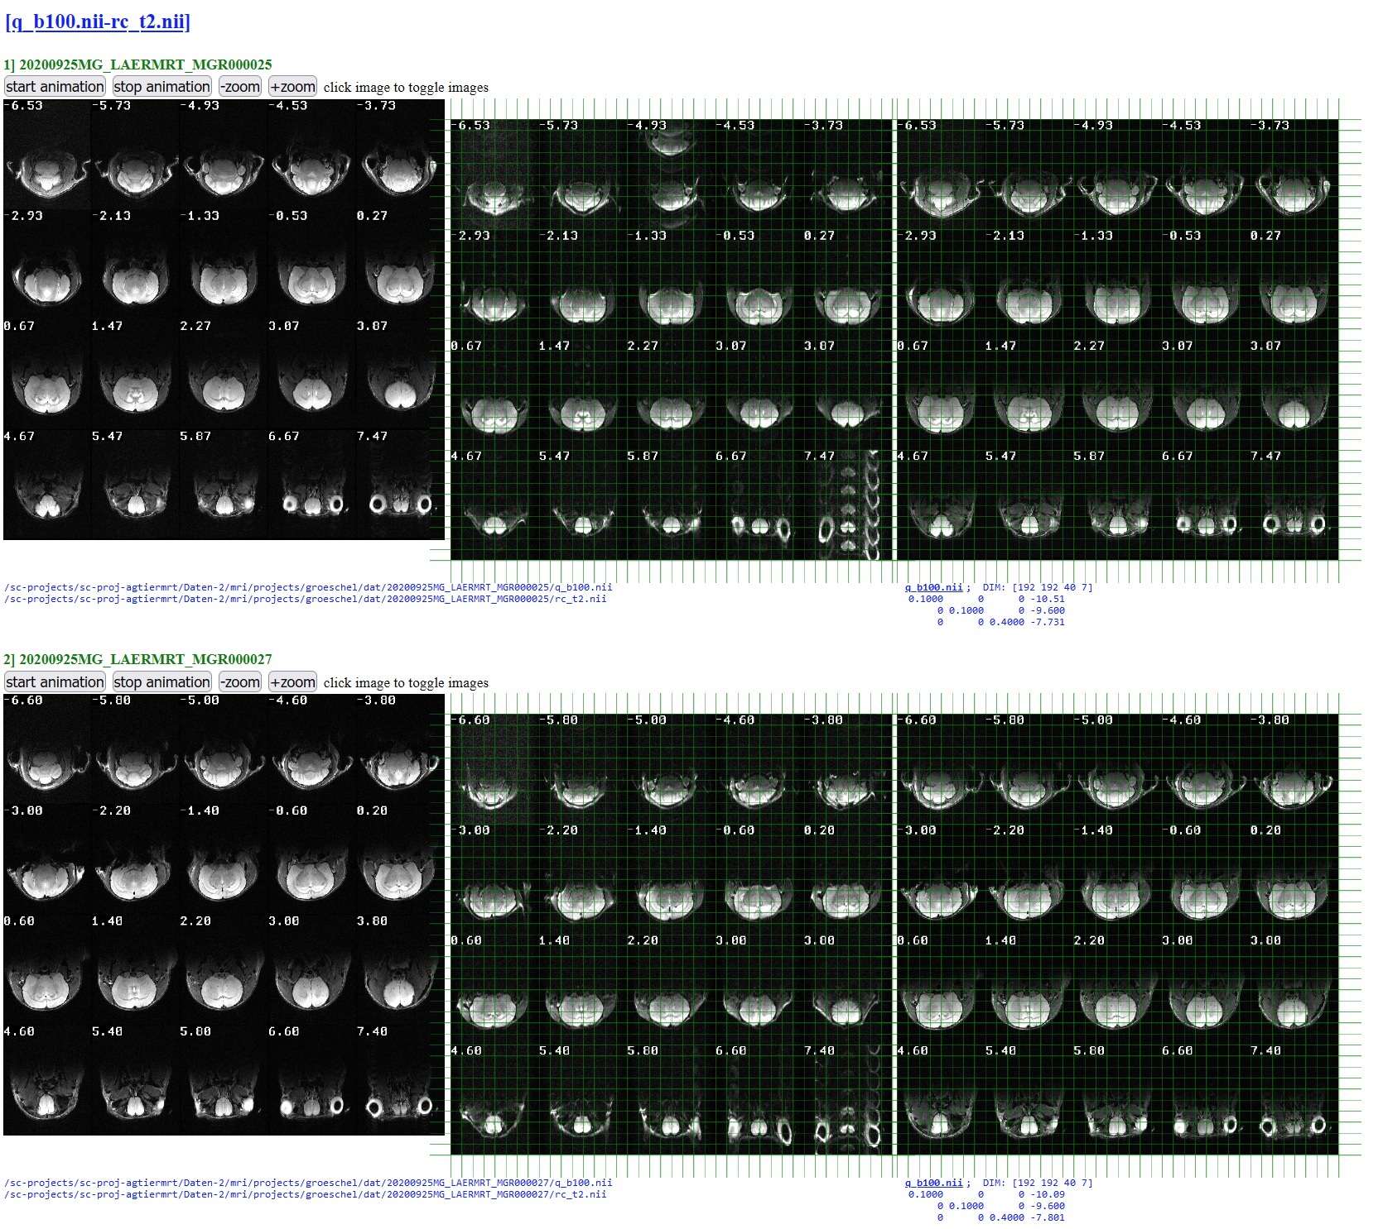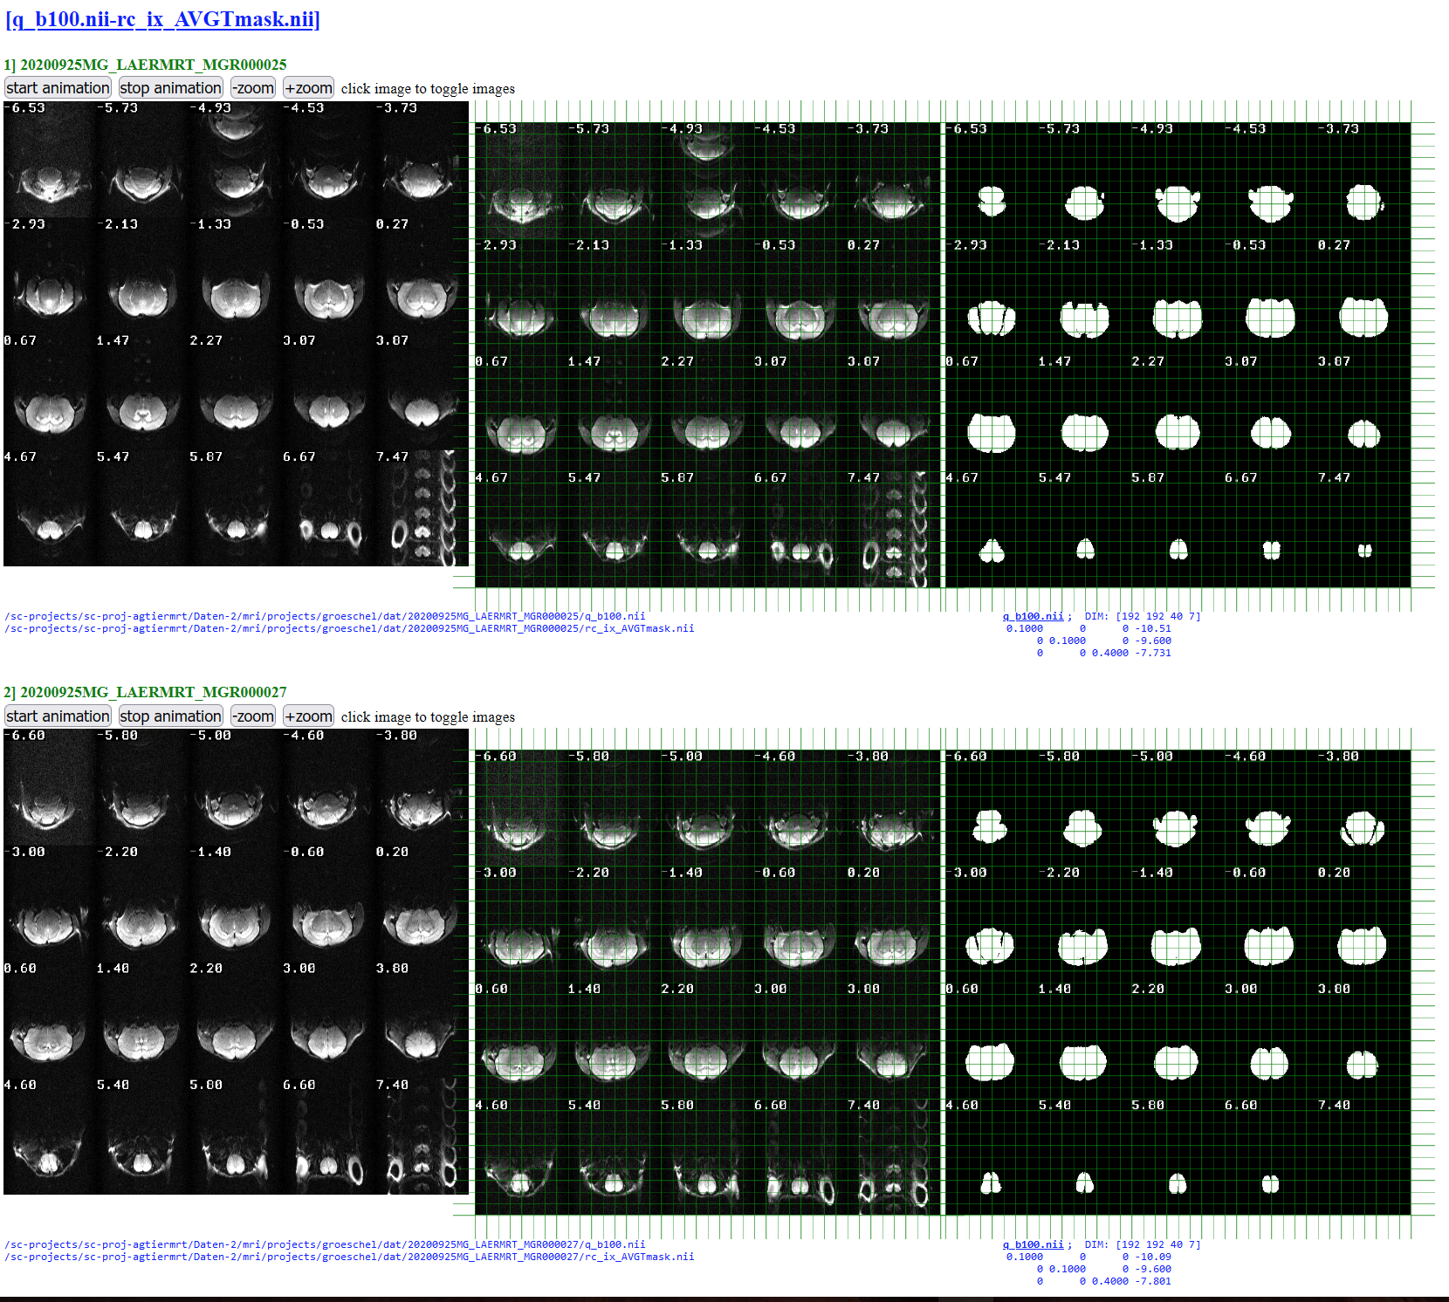

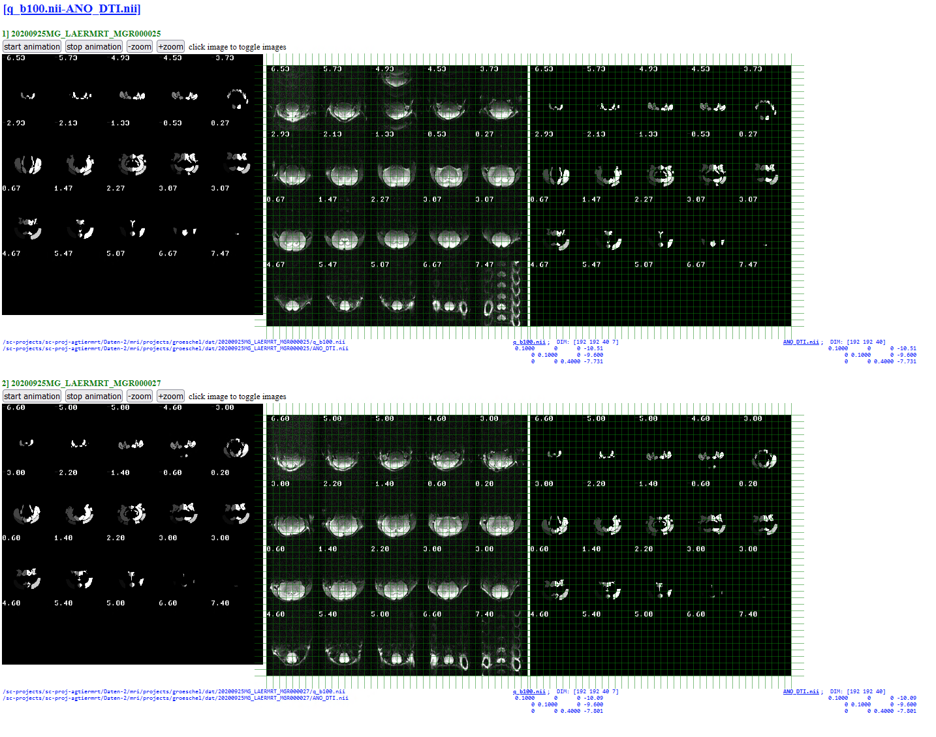

Data seems to be ok. DTI-processing via MRtrix can be done!

**…End of this tutorial. More progress is hopefully coming soon.**